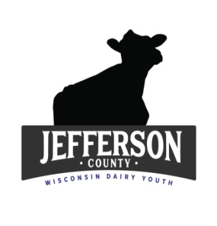
Jefferson County Dairy Youth Scholarship 2023
The Jefferson County Dairy Youth Committee is offering 2 scholarships to Dairy Youth in 4-H/FFA in the amount of $500.00 each to be used for further education in a technical or college degree (any major).
Scholarships are open to all dairy youth in Jefferson County who have been in the project for at least 2 years. Each recipient will receive their check after their first semester transcript has been presented to the Dairy Committee that achieved a minimum of 2.0 GPA. The winners will be announced at the 2023 Jefferson County Fair.
Applications are due on May 12, 2023 to the Extension Office, 864 Collins Road, Jefferson, WI 53549. Applications may be emailed to kimb@jeffersoncountywi.gov, mailed or dropped off at the office.
For questions, please call 920-253-9398. Good Luck!!!!
_____________________________________________________________________________________
Name:
Address:
Email:
Phone:
Parents:
Club/Chapter: Number of Years as a member:
Number of years in Dairy Project:
School planning to attend/Major:
Career Goals:

**Do you own your own dairy cattle or have your projects been managerial?

**List all of the dairy activities you have participated in at the County level only and number of years: (Quiz Bowl, Dairy Judging, Hoards Judging, Fitting/Showing Clinics, Fair, Showmanship, Auction, Fundraisers, Jr. State Fair, Volunteer at Dairy Breakfasts, Etc…)
(You may answer these questions on a separate sheet of paper)
- What has been a personal achievement you accomplished in the dairy project? How did you achieve it?

- What does being a “leader” mean to you? Explain a time when you stepped upped as a leader in the dairy project?

- What do you consider to be the most urgent problem in the dairy industry today and how would you make it better?

**Please also attach to this application:
- A resume of your activities/leadership/community service
- A high school transcript
- A (one) letter of recommendation from a leader, teacher or place of employment

