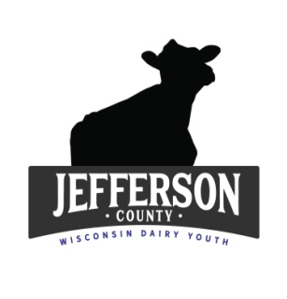
Jefferson County Dairy Youth Scholarship 2021

Name:
Address:
Email:
Phone:
Parents:
Club/Chapter: Number of Years in 4-H/FFA:
Number of years in Dairy Project:
School Attending/Major:
Future Plans:

**Do you own your own dairy cattle or have your projects been managerial?

**List all of the dairy activities you have participated in at the County level only and number of years:
(Quiz Bowl, Dairy Judging, Hoards Judging, Fitting/Showing Clinics, Fair, Showmanship, Auction, Fundraisers, Jr. State Fair, Volunteer at Dairy Breakfasts, Etc…)

(You may answer these questions on a separate sheet of paper)
1. Over the years of being in the dairy project, what has been your biggest challenge and how did you work through it?

2. What were your goals in the beginning of your project years and what was your outcome? (this can be on-farm management or project goals)

3. In the future how do you feel you will continue to promote/support/ stay active in the dairy industry?

**Please attach a resume of your activities/leadership/community service.
**Please attach a high school transcript
**Please attach one letter of recommendation from a leader, teacher, or place of employment
Applications due on June 4, 2021 and sent to UWEX 864 Collins Road, Jefferson, WI 53549 (email here)
Jefferson County Dairy Youth Scholarship 2021
Guidelines:
The Jefferson County Dairy Youth Committee is offering a Scholarship to 2 Dairy Youth in 4-H/FFA for the amount of $500.00 each to be used for further education in a technical or college degree (any major).
This is open to all dairy youth in Jefferson County who has been in the project for at least 2 years.
Each recipient will receive their check after first semester transcript has been presented to the Dairy Committee that achieved a minimum of 2.0 GPA.
Application is due June 4, 2021 to the UWEX (link to fill out application and forward to office & scan additional document)
The winners will be announced at the 2021 Jefferson County Fair.
For questions call: 920-253-9398
Good Luck!!!!

